ASSIGNMENT 8.2
SHRUTHI ADDAGUDI | 2303A52133 | BATCH 37

Task 1 – Test-Driven Development for Even/Odd Number Validator
Use AI tools to first generate test cases for a function is_even(n) and then implement the function so that it satisfies all generated tests
Prompt used:
Generate test cases for a Python function is_even(n) where input must be an integer. The function should handle zero, negative numbers, and large integers.
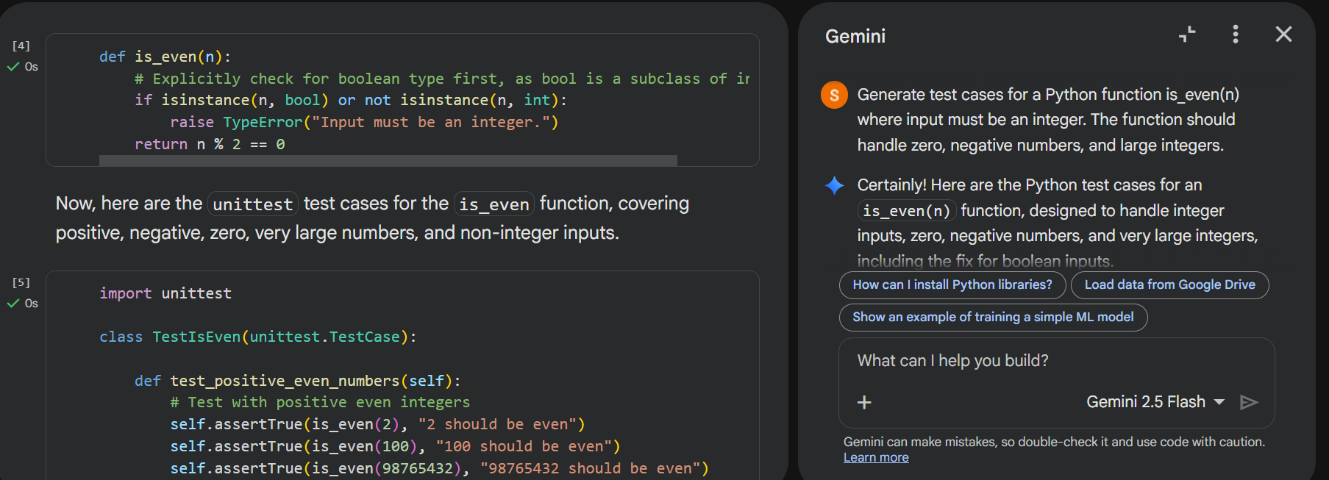
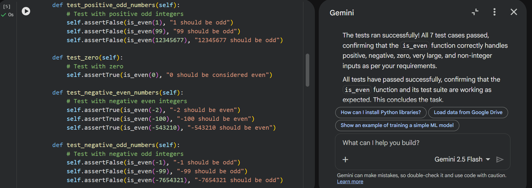
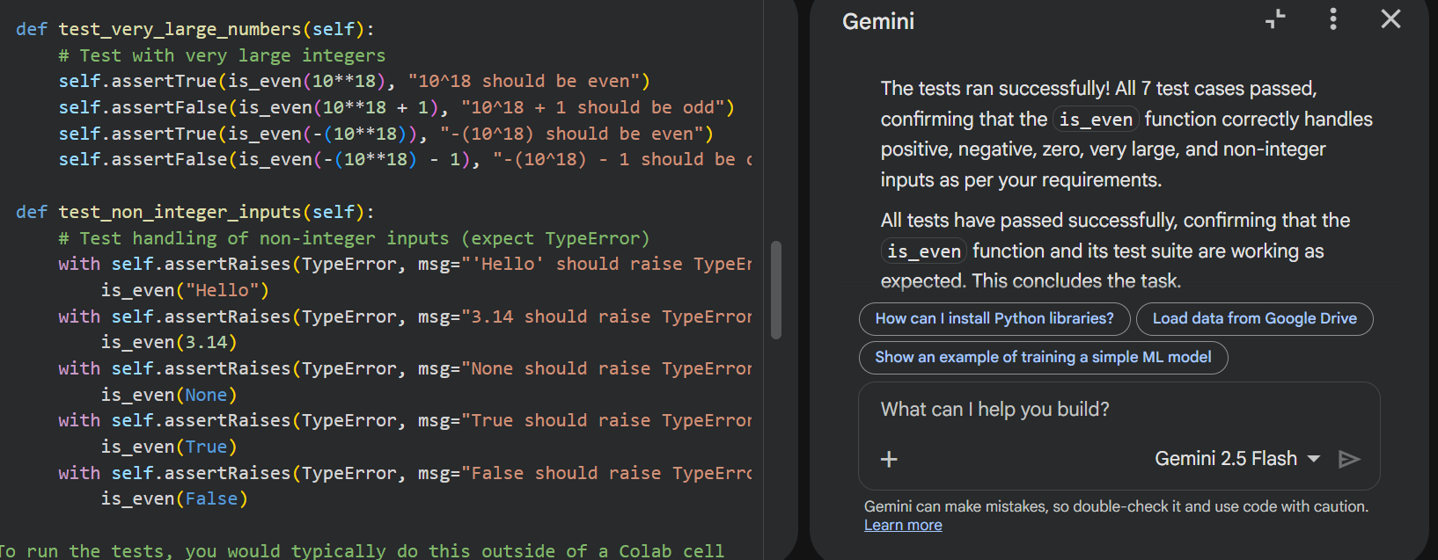
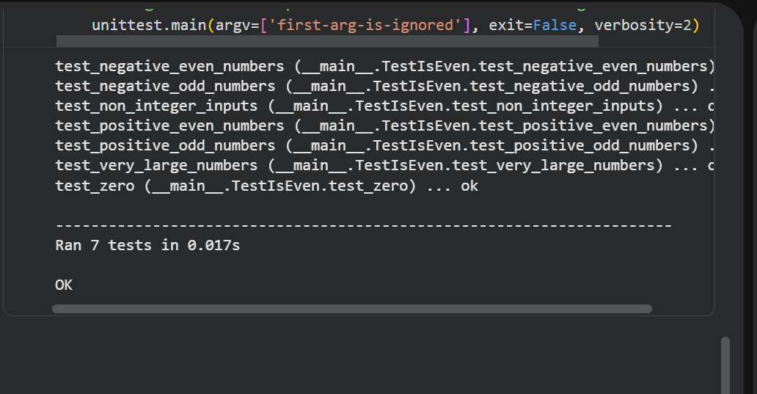
Code Explanation
- isinstance() ensures input validation.
- % 2 == 0 checks divisibility by 2.
- Works for positive, negative, and zero values.

Task Description
Task 2 – Test-Driven Development for String Case Converter
• Ask AI to generate test cases for two functions:
• to_uppercase(text)
• to_lowercase(text)
Prompt used:
Generate test cases for uppercase and lowercase conversion functions that handle empty strings, mixed case, and invalid inputs such as numbers or None.
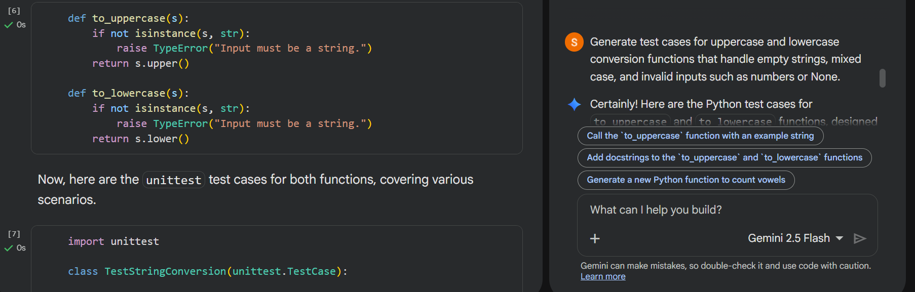
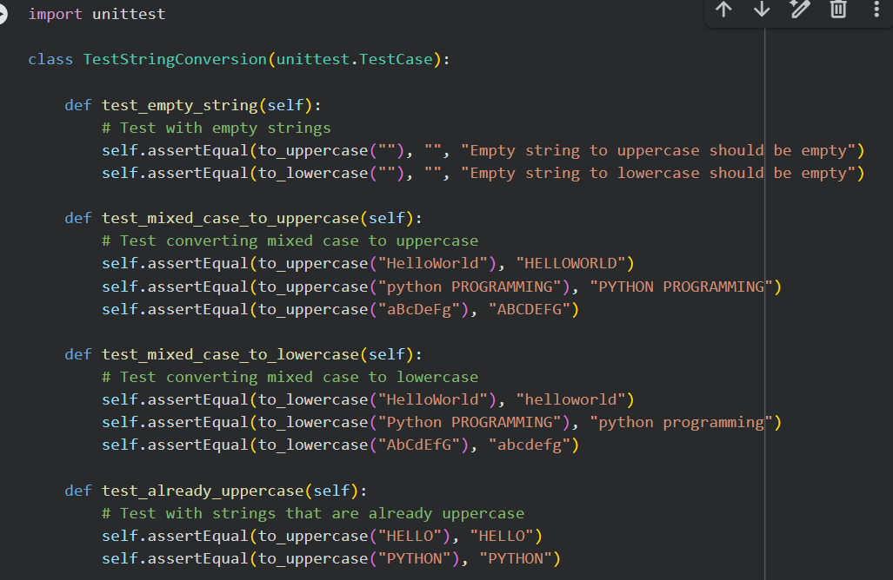
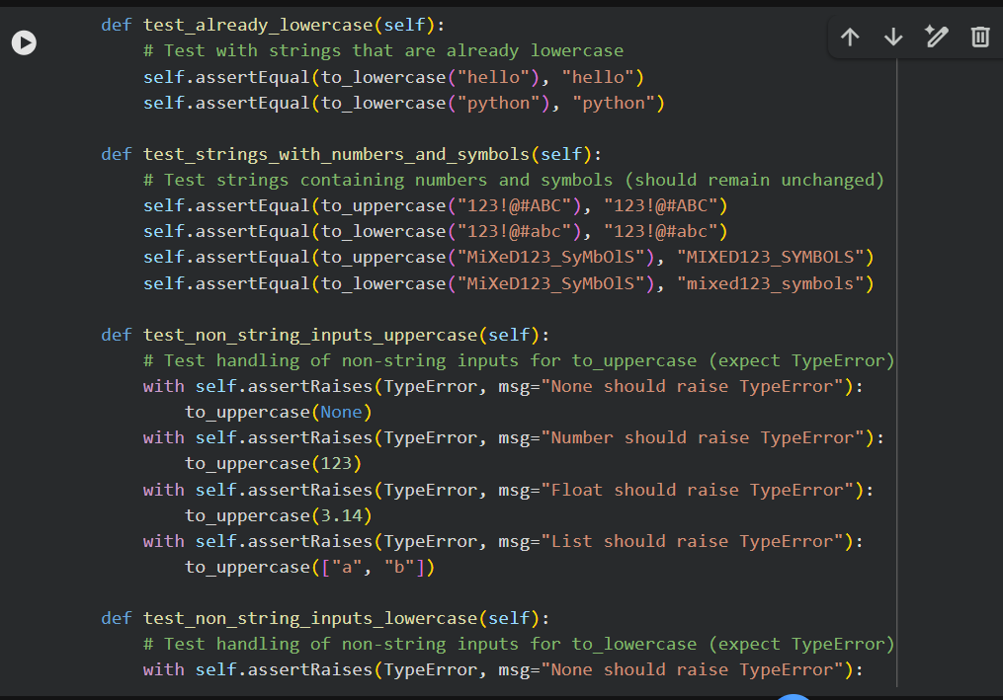
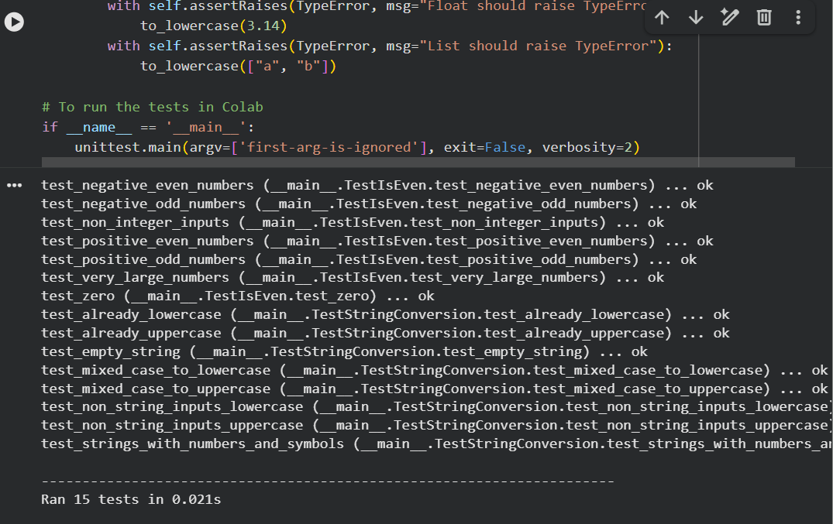
Code Explanation
- Validates input type.
- Uses built-in string methods for conversion.
- Handles empty strings safely.

Task 3 — Test Driven Development for List Sum Calculator
Use AI to generate test cases for a function sum_list (numbers) that calculates the sum of list elements.
Prompt used:
Generate test cases for a function that sums list elements while handling empty lists, negative numbers, and ignoring non-numeric values.
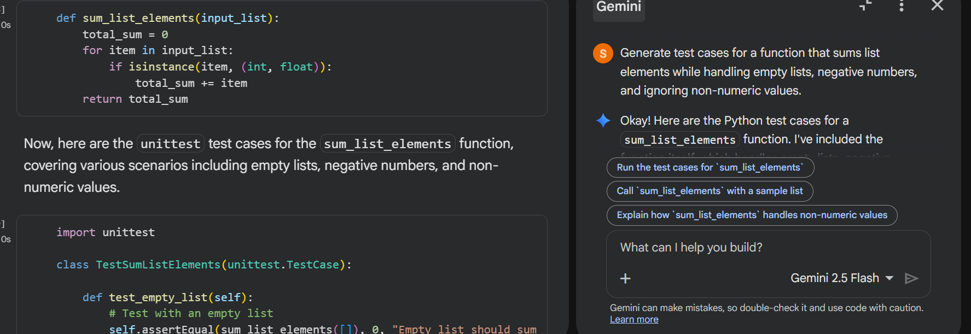
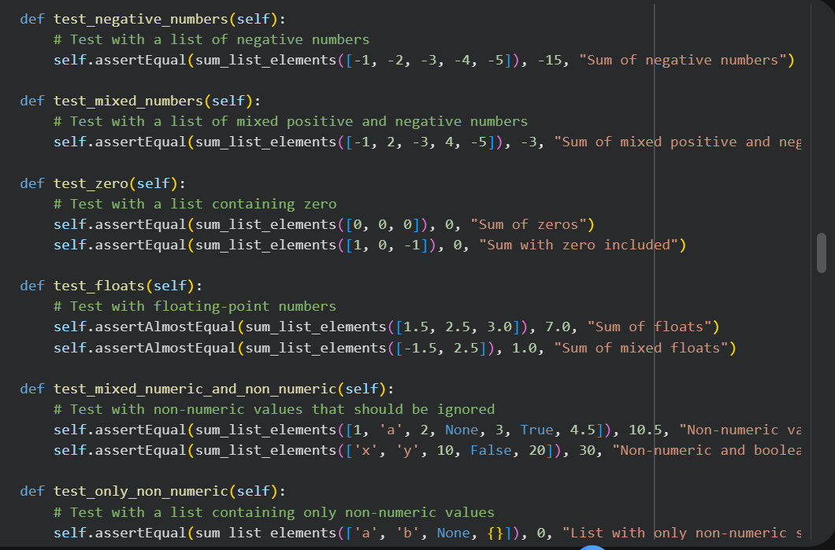
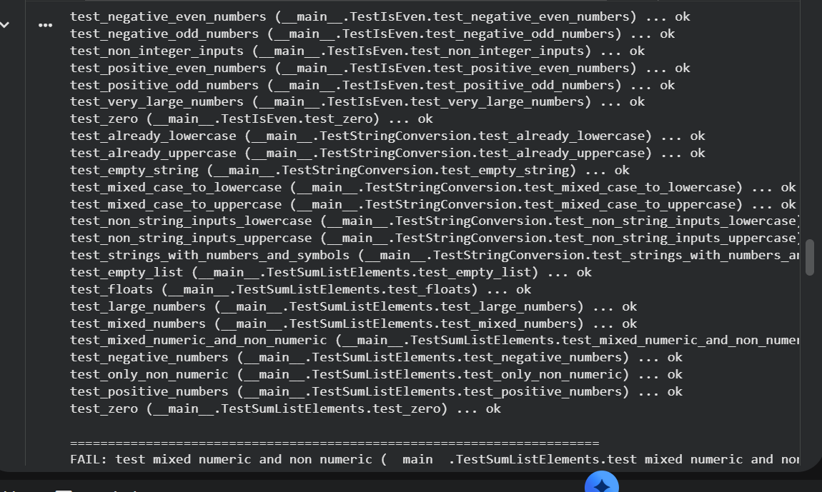
Code Explanation
- Validates list input.
- Ignores non-numeric values safely.
- Works for negative numbers and empty lists.
Task 4 – Test Cases for Student Result Class
• Generate test cases for a StudentResult class with the following
methods:
• add_marks(mark)
• calculate_average()
• get_result()
Prompt used:
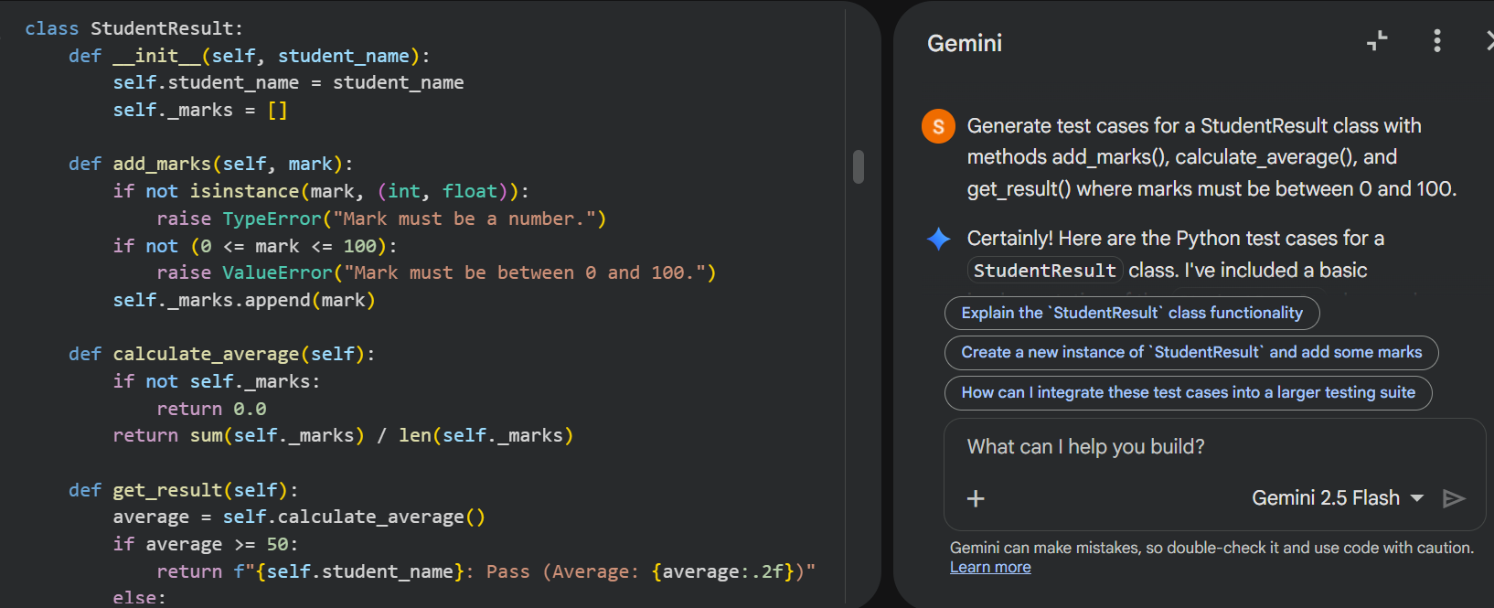
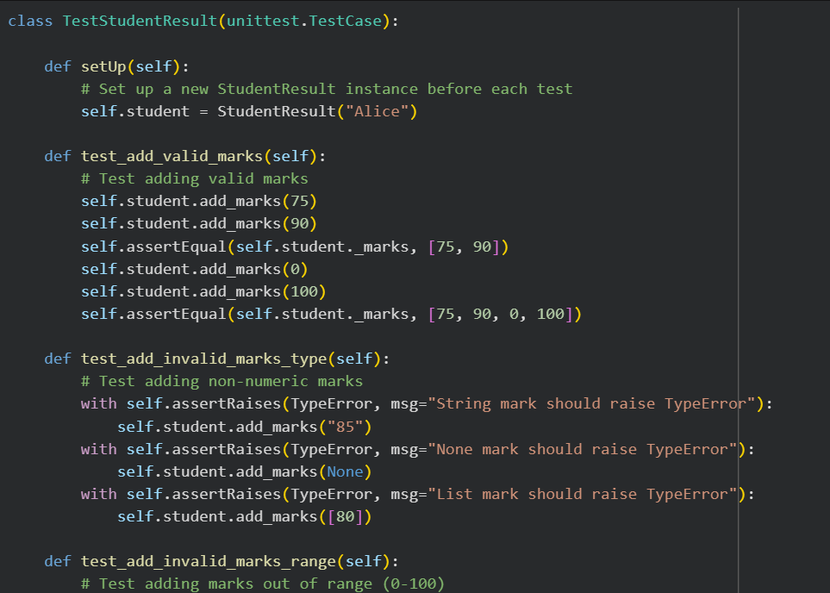
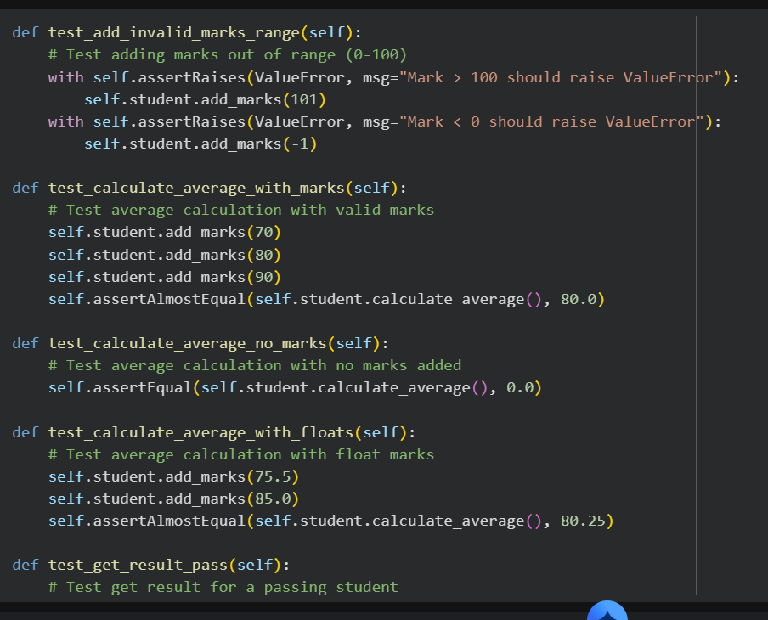
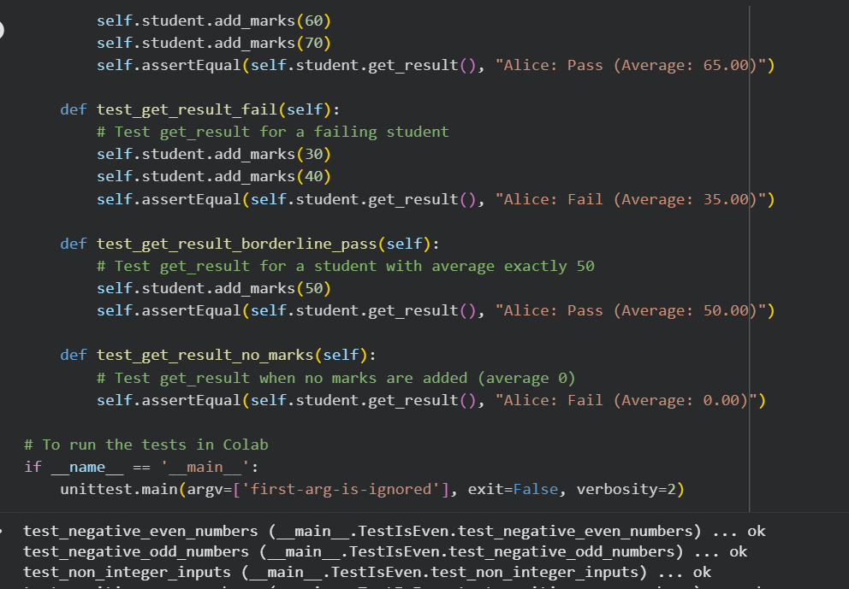
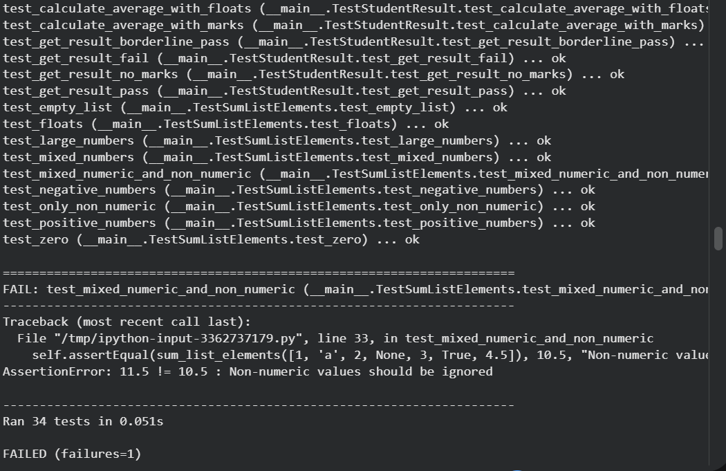
Code Explanation
- Ensures marks are valid.
- Average calculated dynamically.
- Result determined based on average ≥ 40.
Task 5 – Test-Driven Development for Username Validator
Prompt used:
Generate test cases for a username validation function with minimum length 5, no spaces, and only alphanumeric characters.
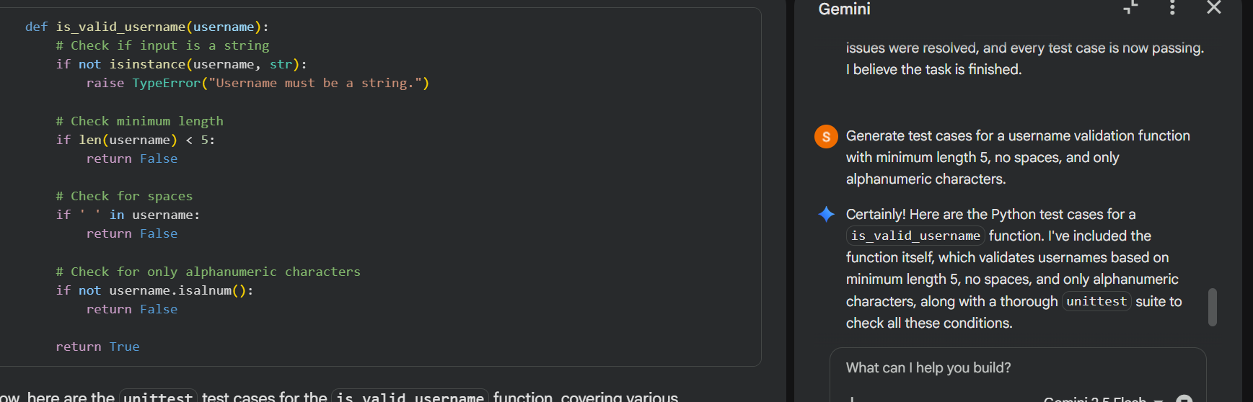
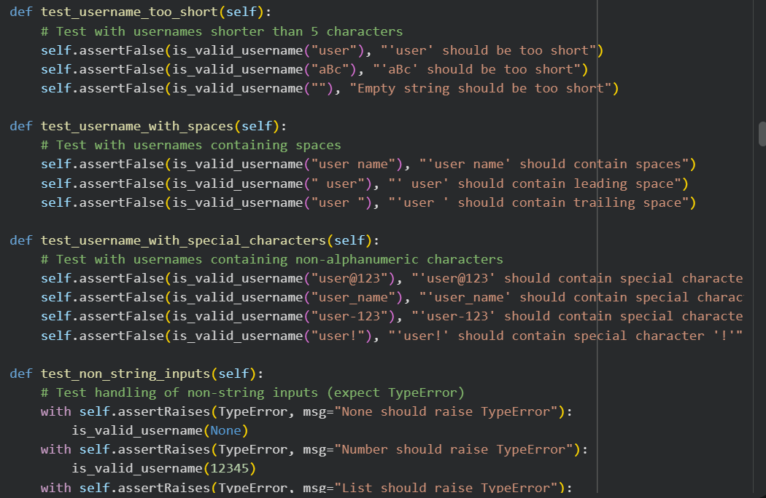
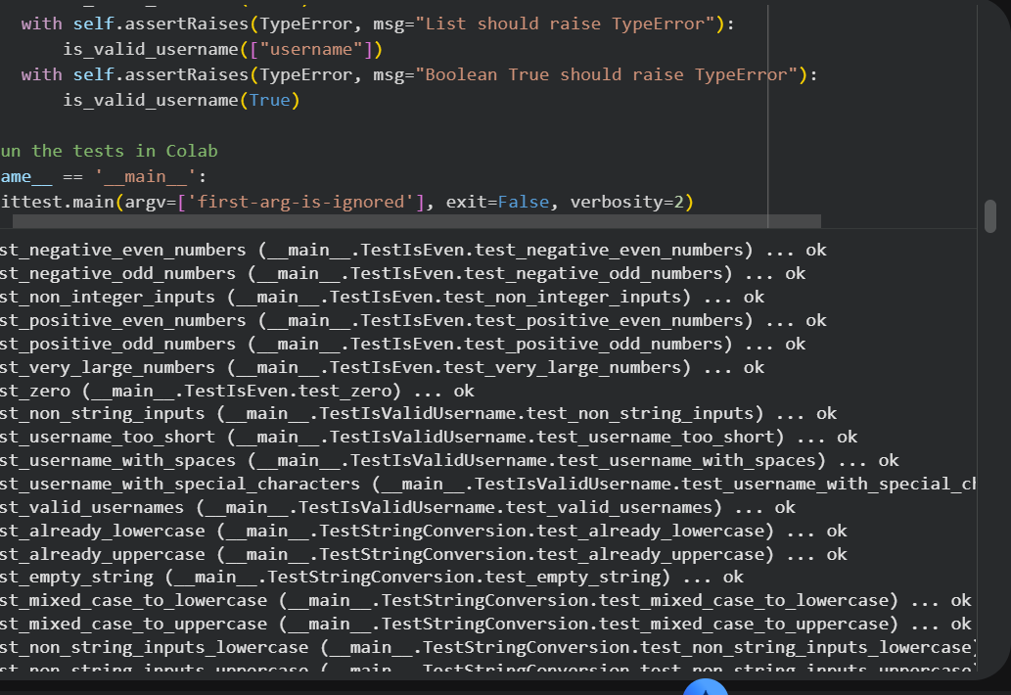
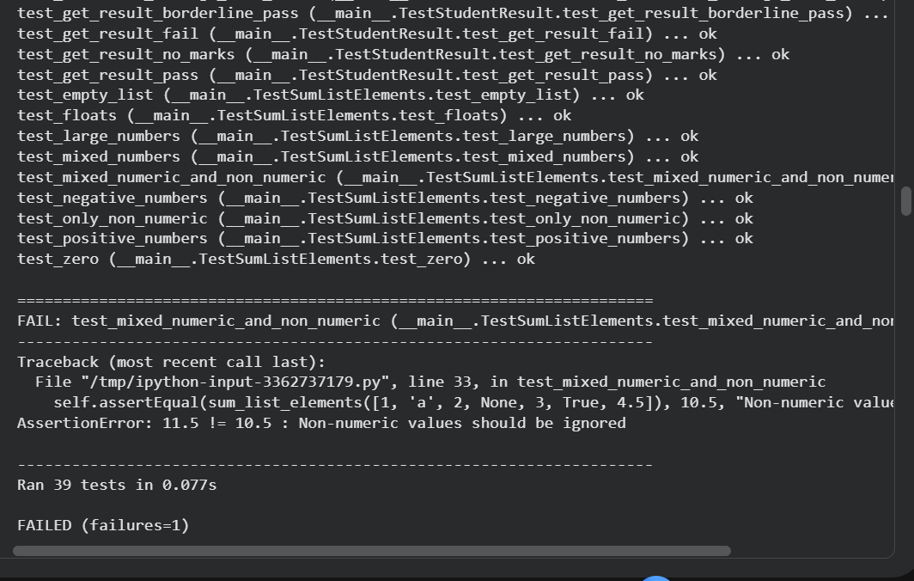
Code Explanation
- Ensures string input.
- Checks minimum length.
- Prevents spaces.
- Allows only letters and numbers.

